

**PRACTICAL FILE**

**OF**

**PROGRAMMING IN C**

**COURSE CODE -CSEG1041**

**SCHOOL OF COMPUTER SCIENCE**

**SUBMITTED BY:**

**NAME: Shagun**

**SAP ID:590025458**

**COURSE :BSC CS**

**SEMESTER:01**

**BATCH:01**

**ACADEMIC YEAR:2025-2026**

Experiment 3: Conditional Statements

***// Write a C program to check whether a number is Even or ODD***

#include <stdio.h>

int main() {

printf("Name -Shagun\n");

printf("SAP ID:590025458\n");

printf("Course - bscCS\n");

printf("batch-01\n");

printf("\n------------------------\n");

int num;

printf("Enter a number: ");

scanf("%d", &num);

if(num % 2 == 0)

printf("%d is Even\n", num);

else

printf("%d is Odd\n", num);

return 0;

}

Output

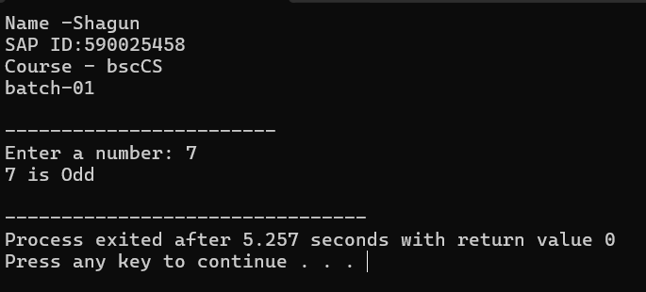

***// WAP to check if the triangle is valid or not. If the validity is***

***established, do check if the triangle is isosceles, equilateral, right***

***angle, or scalene. Take sides of the triangle as input from a user.***

#include <stdio.h>

int main() {

printf("Name - Shagun\n");

printf("SAP ID:590025458\n");

printf("Course - bscCS\n");

printf("batch-01\n");

printf("\n------------------------\n");

int a, b, c;

printf("Enter three sides of the triangle: ");

scanf("%d %d %d", &a, &b, &c);

if((a + b > c) && (a + c > b) && (b + c > a)) {

printf("Triangle is Valid.\n");

if(a == b && b == c)

printf("It is an Equilateral Triangle.\n");

else if(a == b || b == c || a == c)

printf("It is an Isosceles Triangle.\n");

else

printf("It is a Scalene Triangle.\n");

if((a*a == b*b + c*c) || (b*b == a*a + c*c) || (c*c == a*a + b*b))

printf("It is also a Right-angled Triangle.\n");

}

else {

printf("Triangle is NOT Valid.\n");

}

return 0;

}

**OUTPUT:**

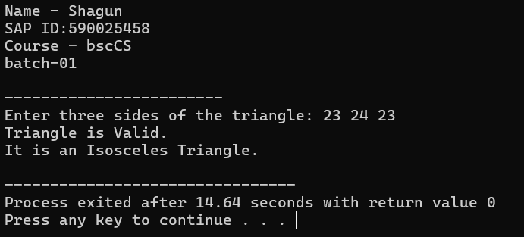

***// WAP to compute the BMI Index of the person and print the BMI***

***values as per the following ranges. You can use the following***

***formula to compute BMI= weight(kgs)/Height(Mts)*Height(Mts).***

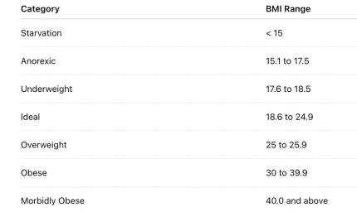

#include <stdio.h>

int main() {

printf("Name - Shagun\n");

printf("SAP ID:590025458\n");

printf("Course - bscCS\n");

printf("batch-01\n");

printf("\n------------------------\n");

float weight, height, bmi;

printf("Enter weight (in kgs): ");

scanf("%f", &weight);

printf("Enter height (in meters): ");

scanf("%f", &height);

bmi = weight / (height * height);

printf("Your BMI is: %.2f\n", bmi);

if(bmi < 18.5)

printf("You are Underweight.\n");

else if(bmi >= 18.5 && bmi < 25)

printf("You are Normal weight.\n");

else if(bmi >= 25 && bmi < 30)

printf("You are Overweight.\n");

else

printf("You are Obese.\n")

return 0;

}

Output:

